# GMV Portfolio - Python Code and Explanation

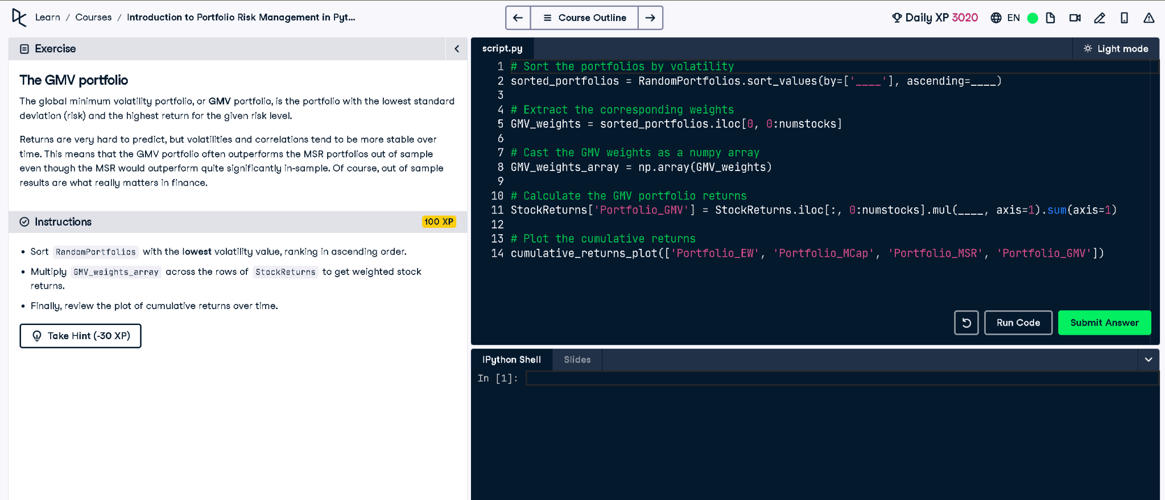

## Python Code

# Sort the portfolios by volatility  
sorted_portfolios = RandomPortfolios.sort_values(by=['Volatility'], ascending=True)  
  
# Extract the corresponding weights  
GMV_weights = sorted_portfolios.iloc[0, 0:numstocks]  
  
# Cast the GMV weights as a numpy array  
GMV_weights_array = np.array(GMV_weights)  
  
# Calculate the GMV portfolio returns  
StockReturns['Portfolio_GMV'] = StockReturns.iloc[:, 0:numstocks].mul(GMV_weights_array, axis=1).sum(axis=1)  
  
# Plot the cumulative returns  
cumulative_returns_plot(['Portfolio_EW', 'Portfolio_MCap', 'Portfolio_MSR', 'Portfolio_GMV'])

## Explanation (in simple words)

The GMV (Global Minimum Volatility) portfolio has the lowest risk. To build it, we sort portfolios by volatility (lowest first), extract the corresponding weights, and calculate returns by multiplying those weights with stock returns. Finally, we plot cumulative returns and compare GMV with other portfolios.